Synnergyze manual for account holders across various processes

Logistics Movement Process:
1. Raw Material Supplier → Provides base materials to manufacturers.
2. Manufacturing Unit → Converts raw materials into finished goods.
3. Warehouse Storage → Stores finished products for distribution.
4. Regional Distribution Centre → Manages inventory for local deliveries.
5. Retailer/Store → Products are moved to retail stores or online fulfilment centres.
6. Final Customer Delivery → The product reaches the end customer.
Key Features:
✔ Clear Logistics Flow Representation
• Step-by-step tracking of product movement from suppliers to customers.
• Regional Distribution Centre ensures optimised routing before retail availability.
✔ Cyclical Movement for Continuous Supply Chain
• Raw materials feed into manufacturing, which funnels into retail & delivery.
✔ Colour-Coded for Clarity
• Light Green Nodes → Represent product-holding & transit points.
• Black Arrows → Indicate the movement of goods through the supply chain.

Financial Process Flow:
1. Purchase Order Issued → (March 1 - March 5)
2. Vendor Payment Processing → (March 6 - March 10)
3. Manufacturing & Production → (March 11 - March 20)
4. Invoice Generation → (March 21 - March 23)
5. Escrow Fund Release → (March 24 - March 26)
6. Logistics & Delivery → (March 27 - March 30)
7. Final Customer Payment → (March 31 - April 2)
Key Features:
✔ Dynamic Calendar Integration
• X-axis follows an actual date range, making it easy to track real-time progress.
• Intervals set every 3 days for clear visibility of workflow phases.
✔ Colour-Coded Process Stages
• Each financial event is uniquely coloured for differentiation.
✔ Scalable for Real-Time Fund Tracking
• Can be expanded to include escrow confirmations, reconciliation milestones, or payment failures

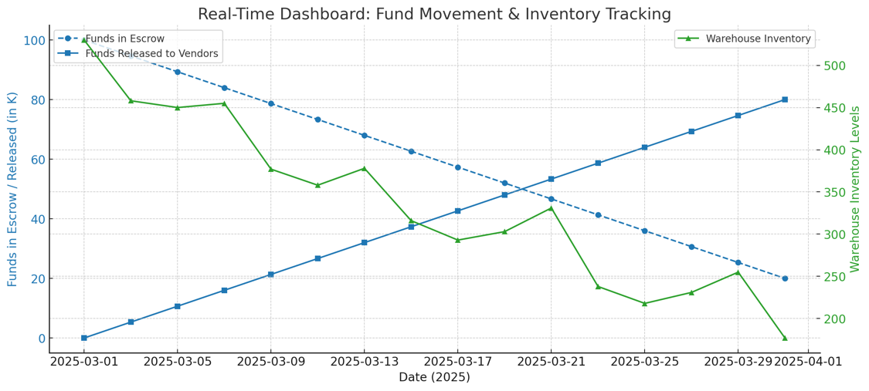

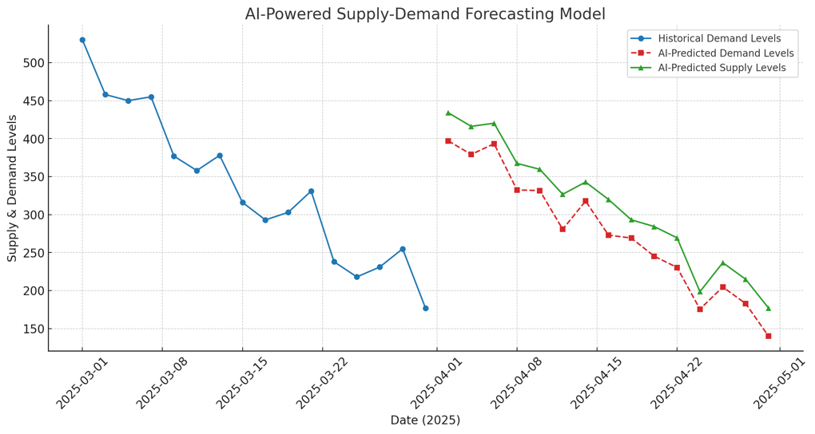

How The synnergyze account works and looks
Key features in UI:
✔ No Overlapping Text or Nodes
• All elements are clearly spaced out, ensuring readability.
• Workflow nodes, role positions, and SCM layers are separated for clarity.

✔ SCM Core Positioned at the Top
• “SCM Core” governs the entire supply chain.
• “License Hub” is directly below, handling financial flow & governance.

✔ Side-Aligned Business Functions
• Sales & Manufacturing (E-Commerce Platform 1) on the left.
• Inventory & Warehouse (E-Commerce Platform 2) on the right.
• Financial & Compliance layers are placed at the bottom.

✔ Distinct Workflow Modules Clearly Labeled
• Each business function is inside the SCM skeleton.
• Workflow labels are positioned separately above their respective processes.

✔ Role-Based Hierarchy Integrated Without Clutter
• Dashed lines link roles to their respective responsibilities.
• Roles are positioned below SCM functions to ensure clarity.

Key visualisation elements :
✔ SCM Core Layer Integration
• “SCM Core” → The top-level governing hub for self-regulated commerce.
• “License Hub” → Controls financial flow & governance, ensuring compliance.
• “E-Commerce Platform 1 & 2” → Handle Sales, Buying, & Distribution.
✔ End-to-End Process Mapping Inside SCM
• Woven Supply (Manufacturing & Production Flow) → Placed under E-Commerce Platform 1.
• Commune Connect (Inventory & Warehouse Management) → Connected with E-Commerce Platform 2.
• Financial Reconciliation & Last-Mile Compliance → Tracks fund flow from Customer to Regulatory Compliance.
• Retail Sales & Final Customer Fulfilment → Located at the bottom of the framework (end of SCM chain).

✔ Clear Hierarchical Role Overlays
• Dashed Lines → Represent role responsibilities for each process.
• Role-Specific Positioning → Ensures structured execution for compliance, sales, logistics, and finance.

✔ Visual Distinction Through Colour & Shape Variations
• Sky Blue → Sales & Manufacturing Operations (Woven Supply)
• Light Green → Warehouse & Inventory Control (Commune Connect)
• Light Coral → Financial Reconciliation & Compliance
• Gold → Retail & End-User Engagement

✔ SCM Completeness
• The entire process is encapsulated, ensuring visibility across governance, finance, operations, and distribution.
Role based Features

✔ Clear Role-to-Workflow Mapping
• Each business function is now correctly linked to its responsible role.
• Dashed lines represent the role’s influence over a specific workflow phase.

✔ Distinctive Workflow Modules with Proper Separation
• Purchase Order & Manufacturing → Sky Blue
• Inventory & Warehouse Management → Light Green
• Financial Reconciliation & Last-Mile Compliance → Light Coral
• Retail Sales Execution & Fulfilment → Gold

✔ Structured Roles for Self-Governing System
• Purchase Manager → Oversees Buyer POs
• Vendor Coordinator → Manages Vendor SOs
• Production Head → Controls Manufacturing
• Warehouse Supervisor → Handles GRN & Stock
• Finance Controller → Escrow & Payment Release
• Compliance Officer → Ensures Financial & Process Compliance
• Sales Manager → Drives Retail Sales & Customer Service

✔ No Overlapping Elements – Fully Scalable
• Roles and workflows are distinct while maintaining logical business flow.

Modules overview

1. Purchase Order & Manufacturing Flow (Woven Supply)
2. Inventory & Warehouse Management (Commune Connect)
3. Financial Reconciliation & Last-Mile Compliance
4. Retail Sales Execution & Final Customer Fulfilment

✔ Colour-Coded Workflow Modules
• Sky Blue → Purchase Order & Manufacturing (Woven Supply)
• Light Green → Inventory & Warehouse Management (Commune Connect)
• Light Coral → Financial Reconciliation & Last-Mile
• Gold → Retail Sales Execution & Fulfilment

✔ Distinct Shapes for Each Module
• Square (■) → Purchase Order & Manufacturing
• Circle (●) → Inventory & Warehouse Management
• Diamond (◆) → Financial Reconciliation & Last-Mile
• Triangle (▲) → Retail Sales Execution & Fulfilment

✔ Clearly Separated Sections
• No overlapping text or nodes
• Each workflow is structured separately while being part of the unified system

✔ Logical Flow Representation
• Edges & Arrows represent how each phase transitions into the next

Topic wise potential outcomes for a client within their synnergyze accounts

1. Retail Store Segmentation & Strategy
• Understanding A+, A0, A- store classifications
• Consumer engagement strategy for each category
• Price points and sales-through evaluation
• Stock rotation every 120 days (ABC methodology)
• Rules for store-based allocation & price discounting

2. Smart Inventory & Sales Flow
• AI-predicted demand vs. actual demand trends
• Old stock clearance mechanisms (offer-based sales, reallocation to lower-tier stores, etc.)
• 50K+ launch strategies and product allocation planning(for instance)

3. AI-Driven Financial & Compliance Framework
• Escrow-based payment flow from retail to vendors
• How funds move between different entities in the ecosystem
• Regulatory oversight and compliance audits

4. Logistics & Distribution Optimisation
• Warehouse stock replenishment & logistics tracking
• Smart contract-driven order fulfilment & financial settlements

5. Energy & Waste Management Insights
• AI-driven power consumption tracking
• Waste categorisation & reduction techniques
• Operational cost reduction strategies
Summary
Key Components & Automation Flow:
1. AI Demand Forecasting (Light Blue Nodes)
• Predicts future stock needs and triggers smart contract-based reordering.
2. Smart Order Placement (Light Blue Nodes)
• Automatically places vendor orders based on forecasted demand levels.
3. Vendor Production & QC (Light Green Nodes)
• Ensures quality control (QC) validation before products move to warehouses.
4. Warehouse Stock Replenishment (Light Green Nodes)
• AI-driven stock management improves storage and logistics.
5. Regional Distribution & Last-Mile Tracking (Gold Nodes)
• Smart contract-based dynamic routing of shipments.
• Live tracking & AI-based route optimisation for last-mile delivery.
6. Customer Order Fulfilment (Light Coral Nodes)
• AI ensures real-time inventory adjustment based on sales trends.
7. Financial Compliance & Regulatory Reporting (Deep Sky Blue Nodes)
• Automated ledger validation & audit trails for full transparency.
• Regulatory compliance is enforced through smart contract execution.
8. Self-Governing Supply Chain Cycle
• The system operates in a loop, ensuring continuous monitoring, forecasting, and optimisation.

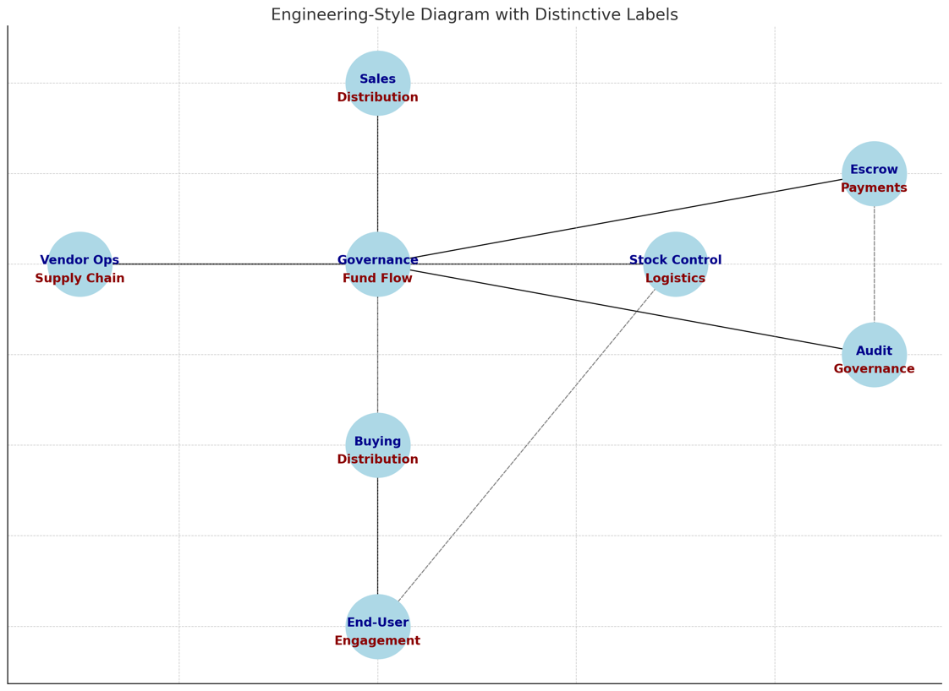
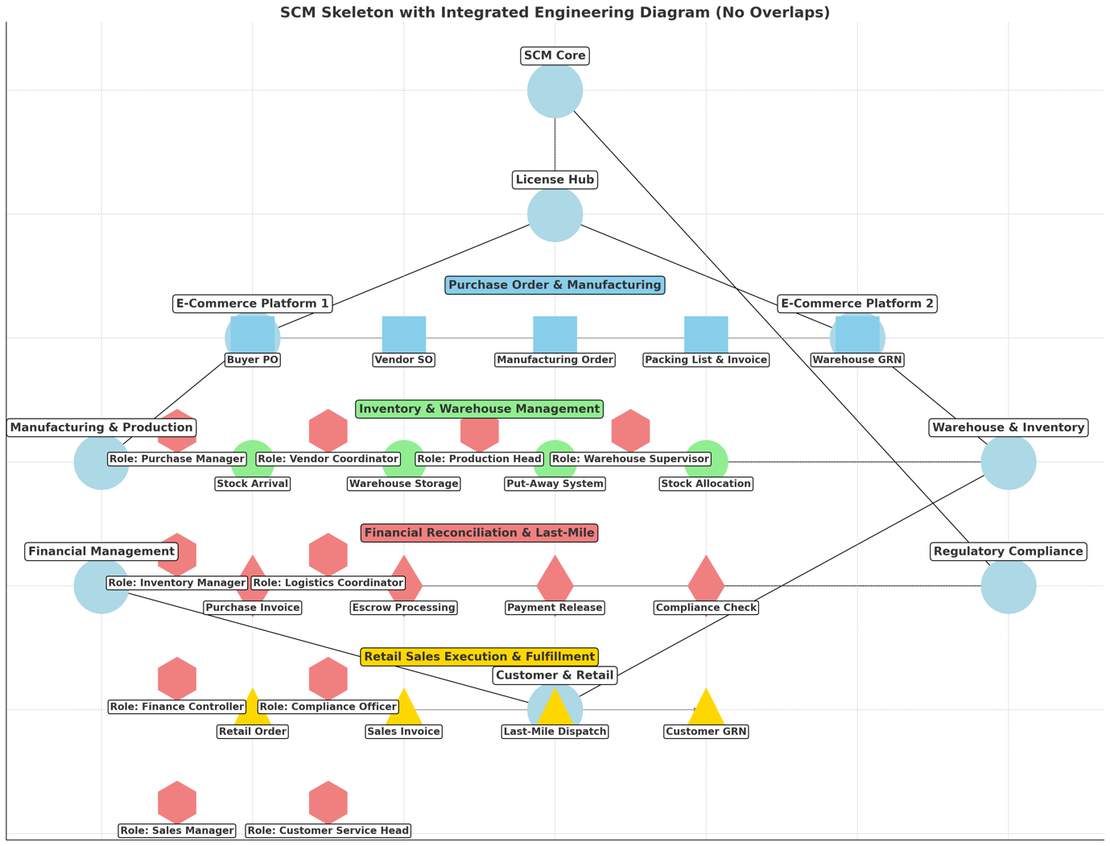
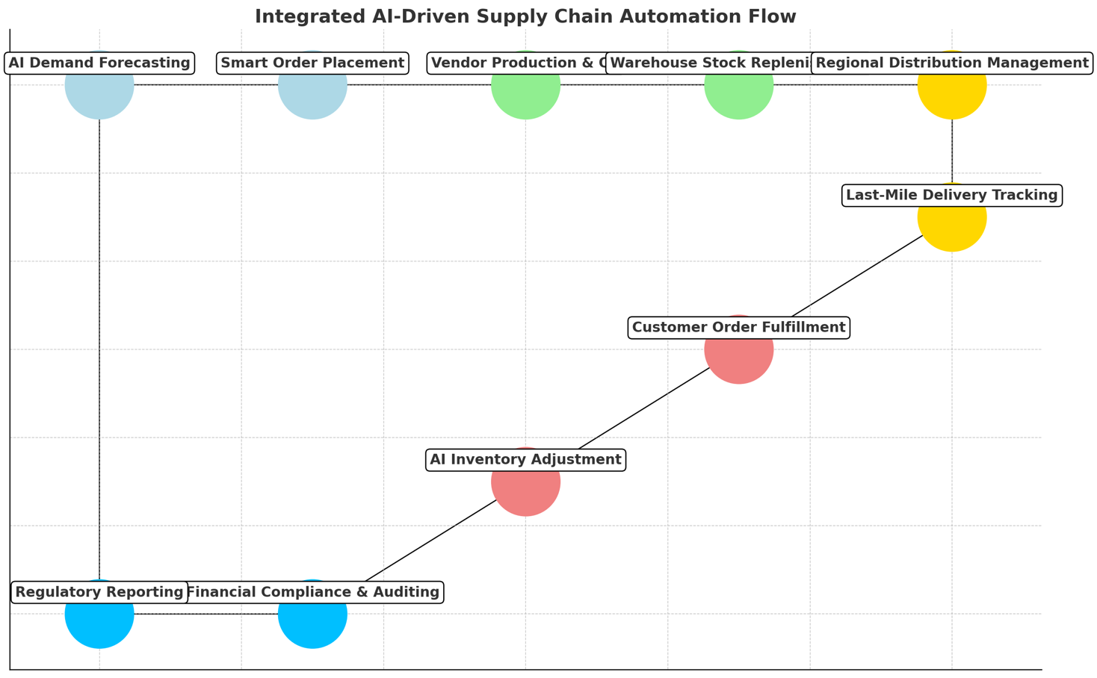
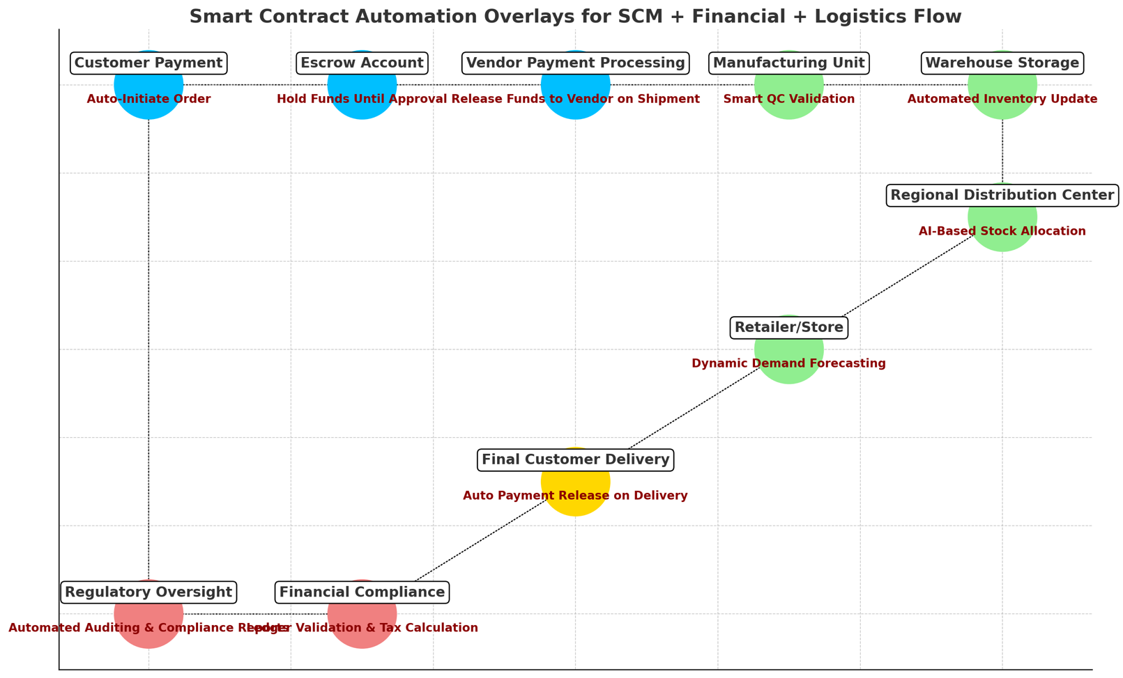

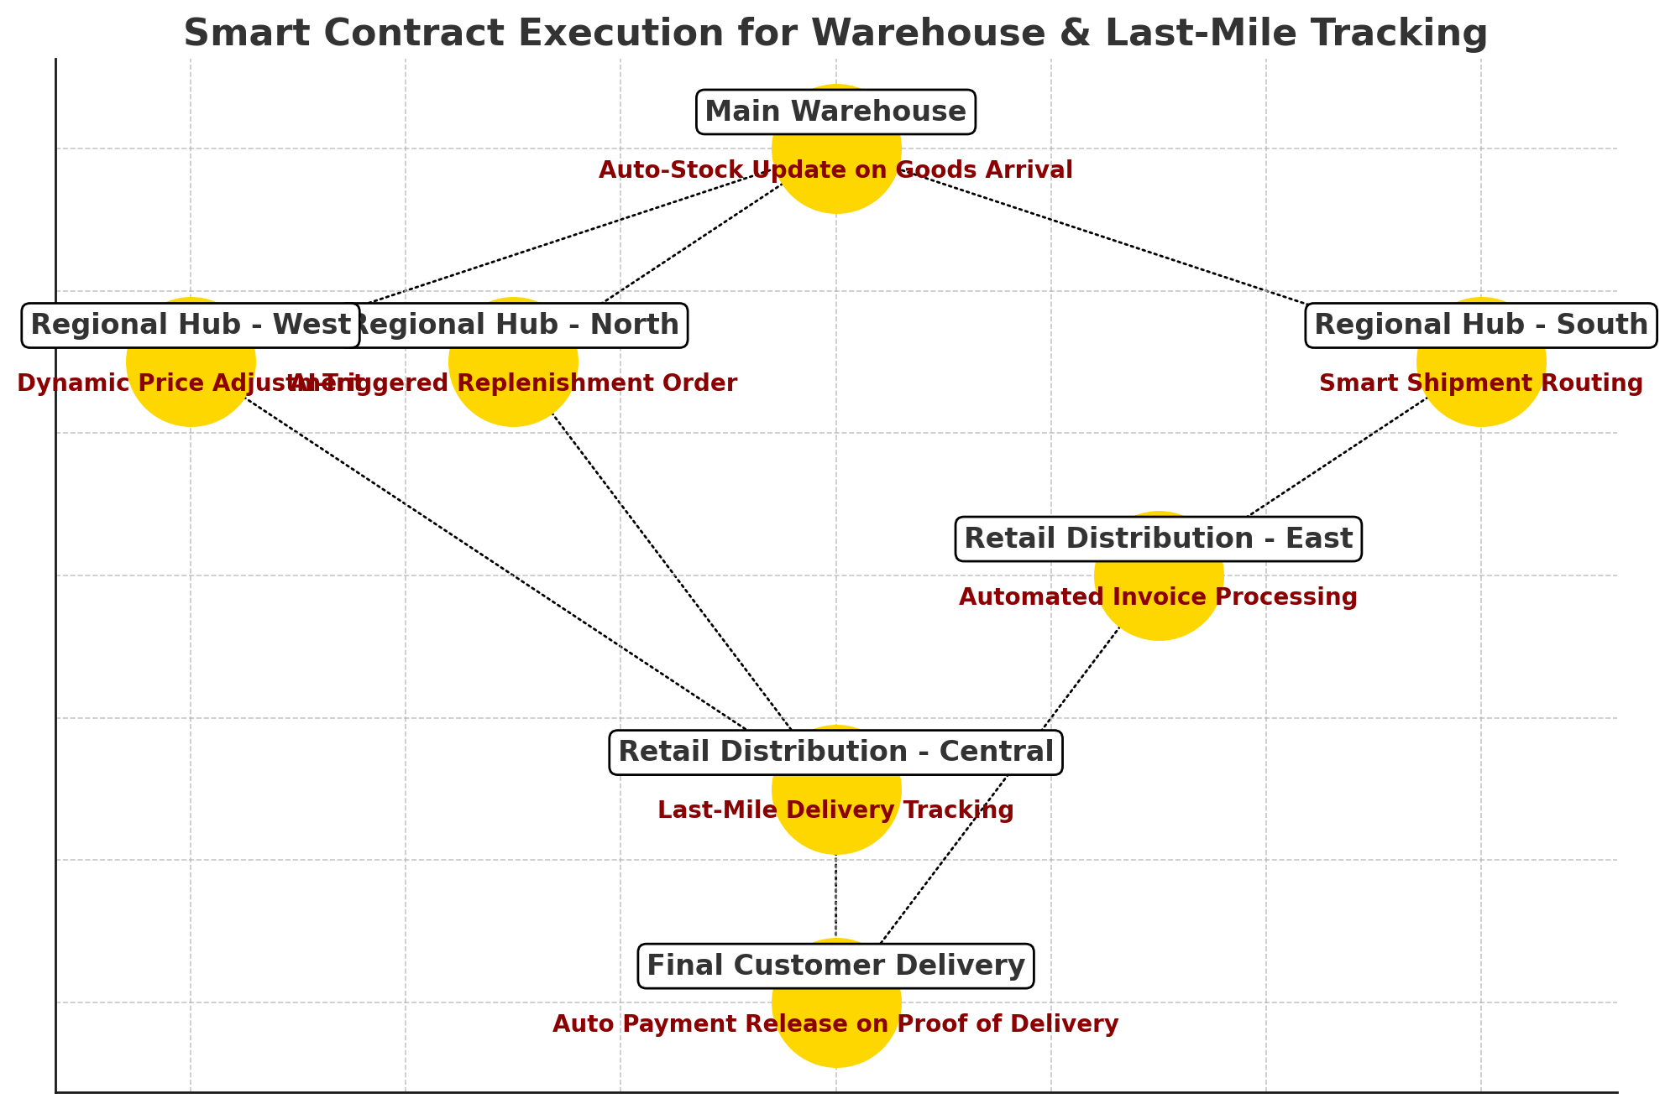

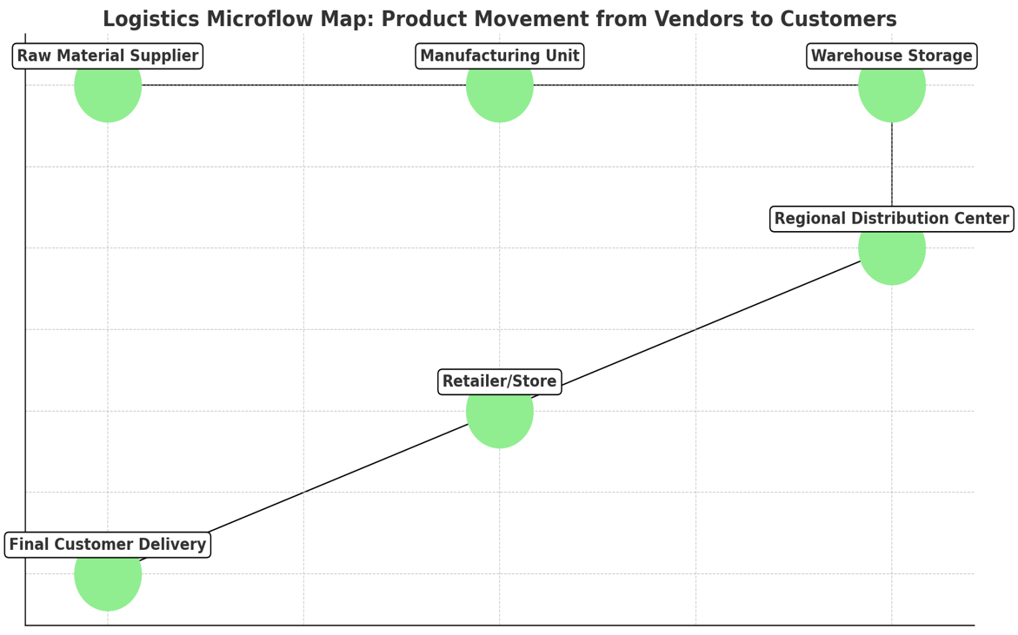
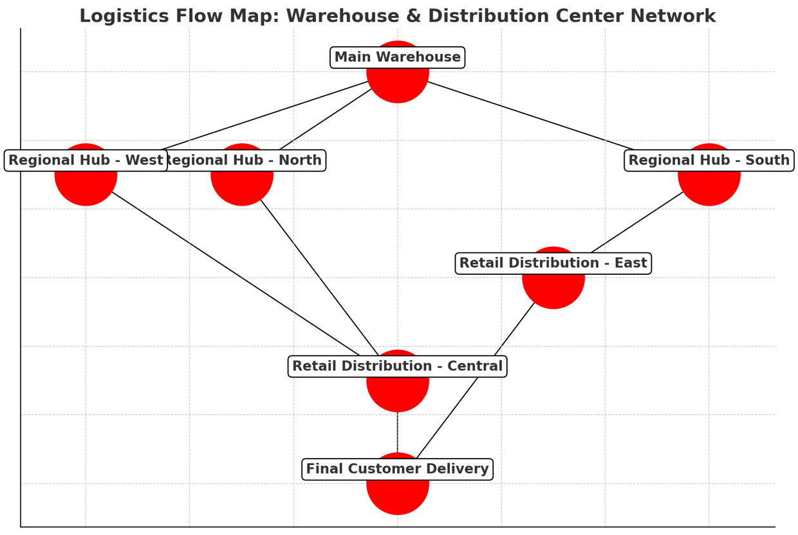
Control Centre or dashboard for your ecosystem might visually look and function, emphasising two distinct yet interconnected marketplace platforms. This control centre serves all entity types as clients, clearly distinguishing between:
1. Supply Marketplace (Woven Supply) – purchasing, sourcing, vendor management, and distribution (supply-side management).
2. Sales Marketplace (Commune Connect) – retail sales, inventory management, consumer engagement, and distribution (retail-side management).

Central Ecosystem Control Centre Layout

Top Layer: Governance & Compliance Hub
• SCM Core (Platform Operator):
• Centralised AI-driven governance module managing ecosystem-wide smart contracts.
• License & Compliance Hub:
• Central layer controlling compliance audits, escrow accounts, regulatory alignment, and financial governance.

Middle Layer: Dual Marketplace Structure

Left Side: Woven Supply (Supply & Vendor Marketplace)
(Supply-side Backbone: Procurement & Distribution Management)
• Core Functions:
• Vendor Management: SO, management, smart orders, vendor relations.
• Sourcing & Procurement: Smart contracts to automate purchase orders.
• Manufacturing & QC: Real-time QC tracking and production status updates.
• Logistics Coordination: AI-driven inbound logistics to warehouses.
• Primary Users:
• Manufacturers, Vendors, Financiers, Platform Operator.

Visual Elements:
• Colour: Sky Blue (Supply and Manufacturing)
• Shape: Squares (■) representing structured supply-chain stages.
• Nodes: clearly segmented steps (PO → Production → QC → Inbound Logistics → Warehouse Entry).

Right Side: Commune Connect (Sales & Retail Marketplace)
(Retail-side Backbone: Inventory & Sales Distribution)
• Core Functions:
• Retail Sales Management: AI-driven sales forecasting and demand analytics.
• Inventory Management: AI-managed stock replenishment and retail allocations.
• Customer Engagement: Retail consumer analytics and segmentation.
• Last-Mile Delivery: AI-optimized delivery and fulfilment tracking.
• Primary Users:
• Brands, Retailers, Logistics Providers, Platform Operator.

Visual Elements:
• Colour: Gold (Retail & Sales Engagement)
• Shape: Triangles (▲) symbolizing sales funnel and customer interaction.
• Nodes: segmented steps (Inventory allocation → Retail Sales → Consumer Engagement → Last Mile Fulfillment).

Bottom Layer: Financial & Operational Reconciliation
• Financial Control & Escrow Management:
• Real-time fund reconciliation, escrow management, financial transparency.
• Compliance & Regulatory Reporting:
• Automated reporting modules ensuring adherence to regulations.
• Operational Transparency:
• Transparent workflow status visualisation from purchase to consumer payment.

Visual Elements:
• Colour: Light Coral (Financial & Compliance)
• Shape: Diamonds (◆) symbolizing financial reconciliation checkpoints.

Cross-Functional Connectors:
• Horizontal Arrows (↔️):
• Linking supply-side marketplace (Woven Supply) and retail-side marketplace (Commune Connect), ensuring seamless integration between procurement and sales.
• Vertical Arrows (⬍):
• Linking marketplaces with Governance Hub at the top and Financial & Compliance hub at the bottom.
• Dashed Lines (– – –):
• Clearly showing role-based access and responsibility mappings to various modules and processes.

Entity Client Roles & Interaction:
Client Entity | Primary Interaction | Marketplaces Accessed
Brands | Retail sales, Inventory control | Commune Connect
Retailers | Consumer engagement, Retail distribution | Commune Connect
Manufacturers | Sourcing, Production, QC | Woven Supply
Vendors | PO & SO management, Supply coordination | Woven Supply
Financiers | Escrow management, Financial reconciliation | Both Marketplaces (financial layer)
Logistics | Warehouse, Inventory, Last-mile logistics | Both Marketplaces (inventory layers)
Platform Operator | Governance, compliance, full system visibility | Entire ecosystem (All marketplaces)
Visual Summary (Dashboard Representation):
+----------------------------------------------------------------------------------+
| SCM CORE GOVERNANCE |
| License & Compliance Management |
+------------------------------⬍----------------------------⬍----------------------+
| WOVEN SUPPLY | COMMUNE CONNECT |
|-------------------------------------------------|--------------------------------|
| ■ Vendor Management | ▲ Retail Sales Management |
| ■ Sourcing & Procurement | ▲ Inventory Allocation |
| ■ Manufacturing & QC | ▲ Consumer Engagement |
| ■ Inbound Logistics | ▲ Last Mile Fulfillment |
|-------------------------------------------------|--------------------------------|
| ↔️ Cross-Marketplace Integration ↔️ |
+------------------------------⬍----------------------------⬍----------------------+
| FINANCIAL RECONCILIATION & OPERATIONAL TRANSPARENCY |
| Compliance & Regulatory Reporting |
+----------------------------------------------------------------------------------+

Key Benefits of this Control Centre Visualisation:
• Clear differentiation between Supply-side and Retail-side ecosystems.
• Seamless integration, enabling dynamic management of workflows across procurement, manufacturing, distribution, sales, and customer fulfillment.
• Role-based clarity and accountability at every interaction level.
• Centralised governance ensuring real-time financial transparency and compliance.

This structured visual ensures optimal clarity, efficiency, and user-friendly management across your entire business ecosystem.
Here’s a structured breakdown of User-based Flows and UI, and a clear depiction of the Master Account UI for the Synnergyze ecosystem, aligned with the ecosystem’s dual marketplace structure and diverse entity types.

A. User-Based Flows & UI

Each entity type has distinct user journeys, interfaces, and functionalities. The UI and flows should be tailored to simplify tasks for each user based on their responsibilities and needs.

1. Brand / Retailer User Flow (Commune Connect Marketplace)

Primary Tasks:
• Inventory allocation
• Retail management (pricing, discounting, promotions)
• Customer analytics & sales reports
• Last-mile tracking

UI Modules & Elements:
• Dashboard (Home):
• Inventory Summary (Stock levels & AI-driven replenishment alerts)
• Sales Analytics & Forecasting
• Active Promotions & Consumer engagement statistics
• Orders & Fulfillment:
• Real-time status of retail orders
• Last-mile delivery tracking visualisation
• Inventory Management:
• ABC segmentation analytics
• AI-driven stock recommendations (reordering, discounting, reallocating)
• Financial & Compliance:
• Transaction ledger
• Escrow account visibility
• Regulatory compliance reporting tools

2. Manufacturer/Vendor User Flow (Woven Supply Marketplace)

Primary Tasks:
• Purchase Orders (PO) & Sales Orders (SO) management
• Production scheduling & QC updates
• Inbound logistics coordination
• Stock & warehouse updates

UI Modules & Elements:
• Dashboard (Home):
• Active Purchase/Sales Orders
• Production Status & Alerts
• QC pass/fail summary
• Order Management:
• PO and SO workflows clearly visualised
• Smart contract automation (order approval/rejection/status updates)
• Logistics Integration:
• Inbound logistics management
• Warehouse stock receipt confirmation
• Financial & Compliance:
• Payment release status (escrow)
• Regulatory compliance checks & audits

3. Financer User Flow (Across Both Marketplaces)

Primary Tasks:
• Escrow-based transaction monitoring
• Fund reconciliation & financial compliance oversight

UI Modules & Elements:
• Dashboard (Home):
• Escrow accounts status
• Pending approvals & reconciliations alerts
• Financial Control Panel:
• Detailed transaction visibility
• Smart contract financial status (auto-payment, holds, releases)
• Reporting & Compliance:
• Regulatory reports & audit trails

4. Logistics User Flow (Across Both Marketplaces)

Primary Tasks:
• Warehouse & inventory management
• Shipment tracking & optimisation
• fulfillment management

UI Modules & Elements:
• Dashboard (Home):
• Warehouse stock overview
• Pending shipments & active deliveries
• Logistics Management:
• AI-optimized route planning & real-time tracking
• Shipment reconciliation and last-mile compliance tools
• Inventory Control:
• Real-time GRN (Goods Receipt Notes) updates
• Stock replenishment status

B. Master Account UI (Platform Operator/Admin UI)

The Master Account UI is a comprehensive, central control panel for the Platform Operator, providing full governance over the entire Synnergyze ecosystem.

Master Account Dashboard Overview:
Core Functionalities:
• Unified Ecosystem Monitoring
• Real-time tracking of all activities across marketplaces.
• Centralised alerts for operational anomalies.
• Role & Access Management
• Create/manage user accounts across entity types (brands, manufacturers, logistics, etc.).
• Allocate specific roles and permissions dynamically.
• Compliance & Regulatory Hub
• Integrated compliance audit trails.
• Real-time regulatory updates & automated reporting.
• Financial Governance
• Escrow and payment visibility across entire ecosystem.
•Dynamic financial reconciliation & reporting.

Master Account UI Structure

Master Account UI Key Features:
• Role-Based Visualisations:
• Clear visualisation of roles, permissions, and workflow accessibility.
• Ecosystem-wide Search & Reporting:
• Unified search function across all transactions and user interactions.
• Generate real-time, customised reports.
• Intuitive Navigation:
• Left-side collapsible navigation with primary modules: Dashboard, Governance, Marketplaces, Roles, Settings.
• Customisable Widgets & Alerts:
• Drag-and-drop UI for arranging widgets based on importance.
• Instant notifications for compliance, financial, or operational issues.

User Journey Example for Master Admin:
• Login → Unified Dashboard → Ecosystem Status Check → Compliance Alerts → Marketplace Activity → Role Management → Financial Reconciliation → Reports & Export Data

Summary of UI/UX Design Principles for Synnergyze:
• Clarity: Distinct separation of marketplaces & roles.
• Consistency: Unified design language, icons, and visual cues across the platform.
• Contextual Visibility: Only relevant data shown based on user type & role.
• Scalability: Design elements capable of handling increased complexity as the platform grows.

This structured UI approach ensures streamlined operations, role clarity, and seamless ecosystem control for Synnergyze’s diverse user base and marketplace structure.
:+------------------------------------------------------------------------------+
| MASTER ACCOUNT (ADMIN PANEL) |
+------------------------------------------------------------------------------+
| SCM CORE GOVERNANCE |
|------------------------------------------------------------------------------|
| [Unified Ecosystem Status] | [Compliance Hub] | [Financial Governance] |
| - Active Orders | - Compliance Alerts| - Escrow Status |
| - Production Status | - Audit Logs | - Payment Releases |
| - Sales & Inventory Alerts | - Regulatory Reports| - Transaction Reconciliation|
+---------------------------⬇️---------------------⬇️---------------------------+
| MARKETPLACE CONTROL & ROLE MANAGEMENT |
|------------------------------------------------------------------------------|
| WOVEN SUPPLY CONTROL | COMMUNE CONNECT CONTROL |
|-----------------------------------|------------------------------------------|
| - PO/SO Status Overview | - Sales Performance & Forecasts |
| - Vendor Management & QC | - Inventory & Allocation |
| - Inbound Logistics Status | - Retail Orders & Last Mile Tracking |
| | - Customer Engagement Insights |
+------------------------------------------------------------------------------+
| USER & ROLE MANAGEMENT |
|------------------------------------------------------------------------------|
| - Manage Brands & Retailers (Commune Connect) |
| - Manage Manufacturers & Vendors (Woven Supply) |
| - Manage Financiers & Logistics Providers |
| - Dynamic Access & Permission Control |
+------------------------------------------------------------------------------+
| SYSTEM SETTINGS & REPORTING |
|------------------------------------------------------------------------------|
| - Workflow Customisation |
| - AI & Automation Settings |
| - Platform Logs & System Health |
| - Data Export & Backup |
+------------------------------------------------------------------------------+

